Lab sheet 10

Question 01

i.



ii.

Question 02

i.

ii.

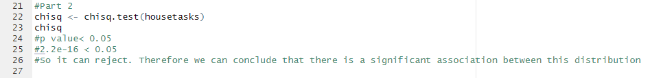

Exercise

